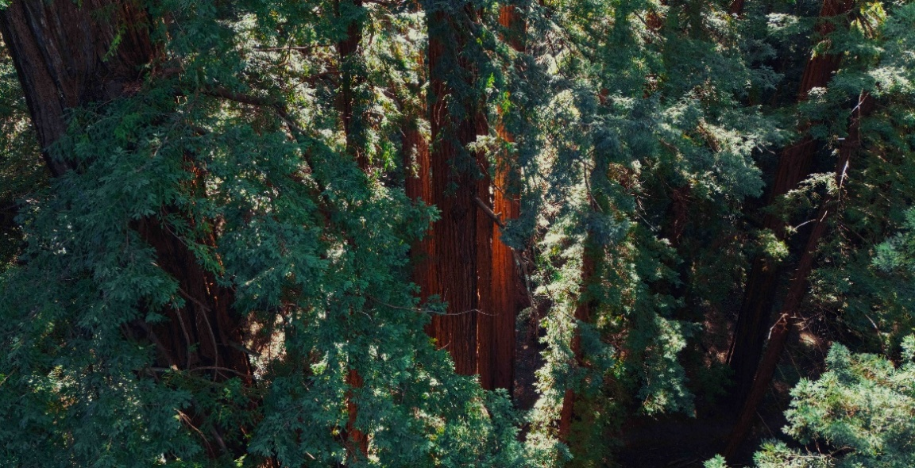Capturing the timeless soundscape of the world’s tallest trees
Nature sound recordist Thomas Rex Beverly used Sennheiser MKH RF condenser microphones to uncover the hidden sounds of an ancient redwood forest

Wedemark, September 2025 – This recording trip truly stands out in the fascinating work of Thomas Rex Beverly, and has left a lasting impression on the field recordist: In March and October of last year, he was allowed to record in an ancient redwood forest and climb one of the gigantic trees to capture its rich soundscape at different heights. With the help of a selection of Sennheiser microphones — including the renowned MKH 8000 Series condenser microphones — Beverly not only sought to document the ambient sound of an untouched forest and the subtle, intimate sounds of one of the redwood trees, but also to preserve and share the auditory essence of the ancient redwood ecosystem.

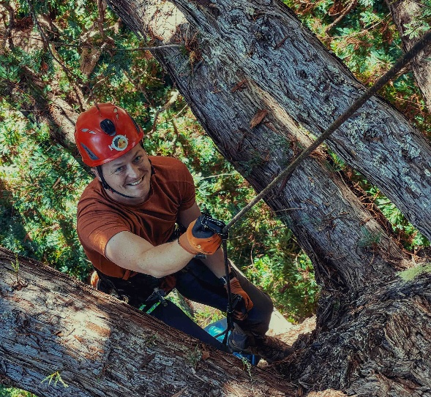 | Thomas Rex Beverly climbing a redwood on the second leg of his expedition

“More people have climbed Mount Everest than have climbed an old-growth redwood tree,” says Beverly, highlighting the fact that these giant trees are strictly protected. It was only when Beverly reached out to the Sempervirens Fund, an organisation dedicated to preserving redwood forests, that he — after careful scrutiny — obtained permission to record up in a redwood. The recordings took place in the heart of California’s Santa Cruz Mountains in a secluded redwood grove protected by the fund. The trees in this conservation area — some growing as tall as 80 metres — are undisturbed by logging, with some believed to be as old as 1000 years. Beverly describes the forest as “amazing”, noting the pristine condition and the opportunity it provided to access trees that had been left untouched for centuries. “It was about ensuring there was minimal noise pollution and that we could access the trees without causing harm,” he explains. “The location was perfect for this kind of deep sonic exploration.”

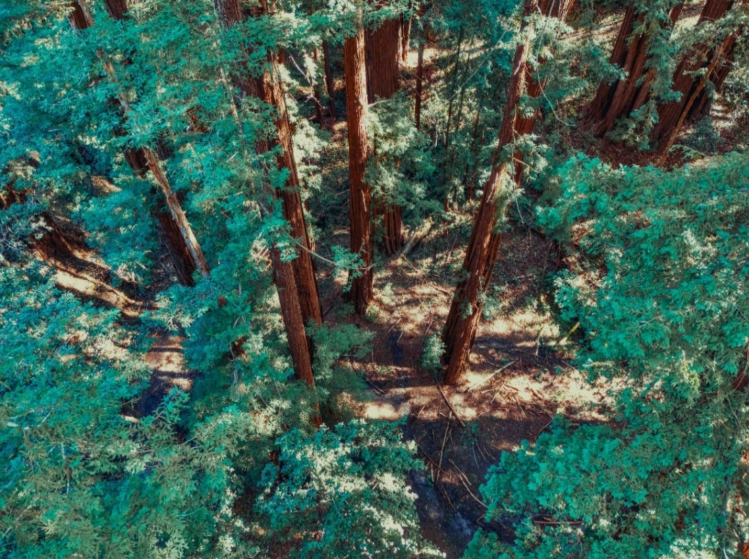
The Sempervirens Fund, an organisation dedicated to preserving redwood forests, enabled Beverly’s sonic expedition into the redwood world

A deep connection with trees
Beverly’s connection to trees runs deep. Growing up in Texas, he often climbed oak trees with his father, fostering a lifelong fascination with old trees. “I’ve always been drawn to the stories trees tell through sound,” he says. “Redwoods, in particular, offer a unique perspective on nature. This project was about capturing not just the sound of the forest, but the essence of the trees themselves.”

Some of Beverly’s primary tools for the project were Sennheiser MKH 8000 Series microphones, which he chose for their clarity, wide frequency response, and ability to capture nuanced, ambient sounds in challenging environments. His setup included the MKH 8020, MKH 8030, and MKH 8040 in various set-ups to capture the redwood grove’s diverse acoustics. The MKH8020 is particularly good for capturing the most subtle sounds of the Redwoods because of its low self-noise and high sensitivity.

“I had a double ORTF setup of Sennheiser MKH 8040s,” Beverly explains. “I was testing directional setups using the MKH 8040 and MKH 8030, pointing the microphones upward to capture the sounds of the tree canopy while recording from the forest floor.”

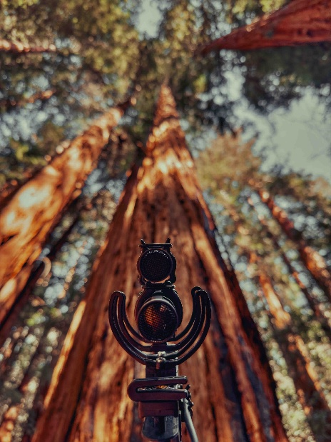 | An MS stereo set-up with an MKH 8030 and 8040

Given the towering height of the redwood trees, capturing sound from multiple vertical layers was a must. Beverly notes, “The difference in sound between the base of the forest and 60-80 metres up is huge. On many trees, the branches don’t even start until about 50 metres high, so recording from the forest floor and then from the canopy gives a totally different sonic perspective.

“So the main goal of the microphones was to record at the base of the tree, at about 30 metres up, 60 metres up and 70 metres up. The mics were all recording in parallel so that when sync’ing them all up, you could hear the same sound from different heights in the tree. For example, when a big wind gust came in, you could hear that at 30, 60 and 70 metres. It gives listeners a deeper look into the micro-ecosystems of the tree.”

Over the course of ten days in March 2024, Beverly positioned multiple microphones in the grove to capture a range of environmental sounds. The setup included spaced omnidirectional microphones, the double ORTF configuration, and experiments with the Sennheiser AMBEO VR ambisonics microphone, which was used to capture spatial audio across the vertical landscape of the trees.

The sounds inside a redwood tree
Perhaps the most striking element of Beverly’s project was his exploration of the sounds inside the trees. Using contact microphones carefully placed directly on the bark, he could record the unique ‘crackling’ sound of water being drawn up through the xylem — the tissue responsible for transporting water and nutrients within the tree.

“Recording the sounds inside the tree was one of the most fascinating parts of the project,” Beverly recalls. “You get this crackling, almost whispering sound as water moves up through the bark. That’s something the MKH 8020s — great for capturing ambient sounds — couldn’t pick up, so the contact mics really helped create that dimension.”

This experiment led to an unexpected discovery. Beverly noticed that certain loud noises, such as the calls of a raven or an owl, were also captured by the contact microphones. “When the raven made a loud enough call, it vibrated the tree, and I could hear it through the contact mic,” he explains. “It was a unique way of experiencing how wildlife calls can vibrate the tree itself.”

The ability to juxtapose the ambient sounds captured by the MKH 8040 microphones with the internal sounds of the tree via the contact mics gave Beverly a deeper sonic insight into this ancient, living organism. “It’s a whole new perspective, and it’s conceptually and sonically fascinating to go from the environment outside the tree to the internal life of the tree itself,” he adds.

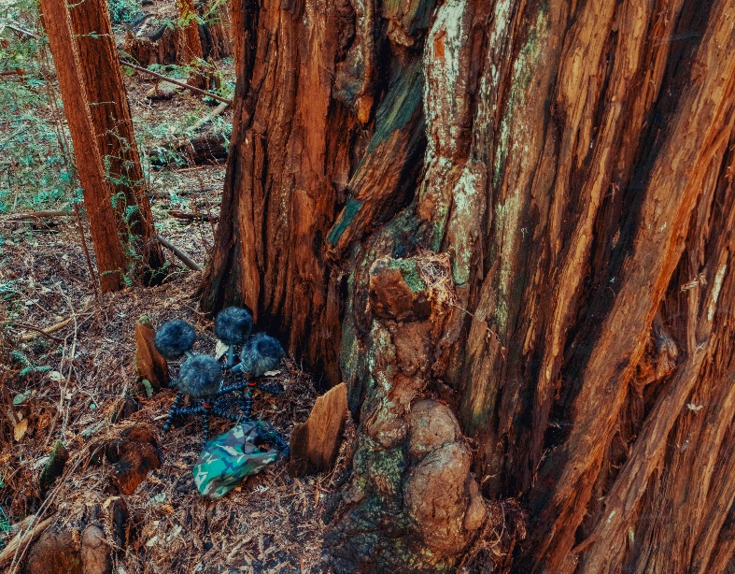 | Four MKH 8040 in a double ORTF configuration at the base of a redwood tree. The mics recorded the outward sounds, while contact mics clipped to the bark recorded the internal sounds of the tree

Recording in the canopy
Following a half-year break to protect a rare bird breeding in the redwoods, the pinnacle of Beverly’s project came in October, when he and two climbing guides set up rigs at varying heights in one of the trees to record the subtle sounds of the tree canopy. This required a multi-day process involving tree-climbing gear, crossbows to shoot ropes over branches, and careful planning to ensure minimal disruption to the tree’s health.

“We started by shooting a fishing line over the top of the branch, which took most of the day. After that, we gradually pulled thicker ropes through and finally set up a climbing rope,” Beverly explains. This process took about three days of meticulous work.

Thomas Rex Beverly and two guides climbing a redwood to record the canopy sounds from various heights | 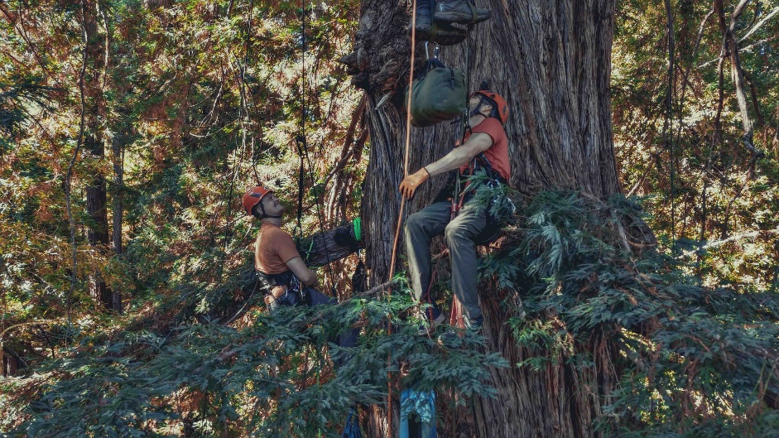

At varying heights within the tree, Beverly placed microphones to capture sound events from different vertical perspectives. He explains: “By having two rigs on the forest floor and three rigs in the tree itself, I could switch between different perspectives if something significant happened, like a branch falling or an animal call.”

By recording not just at the top of the tree, but also at various points in the lower canopy and at the base, the stark differences in sound between these layers of the tree became clear, as Beverly points out, “The wind sounds very different depending on where you are in the tree. The needles in the lower canopy are much bigger because there’s not as much light, and they’re trying to get moisture, while at the top of the tree the needles are much smaller.”

This vertical perspective allowed Beverly to capture the subtle shifts in wind, animal sounds, and even the creaks of branches at different heights. “The quietness of the redwood groves is remarkable. There are few animal species here, so when something does happen — a branch breaking, an animal call — it really jumps out,” he says. “One night, there was a bit of a windstorm that came through and I managed to capture the sound of a giant redwood tree falling. It sounded like an explosion in the distance.”

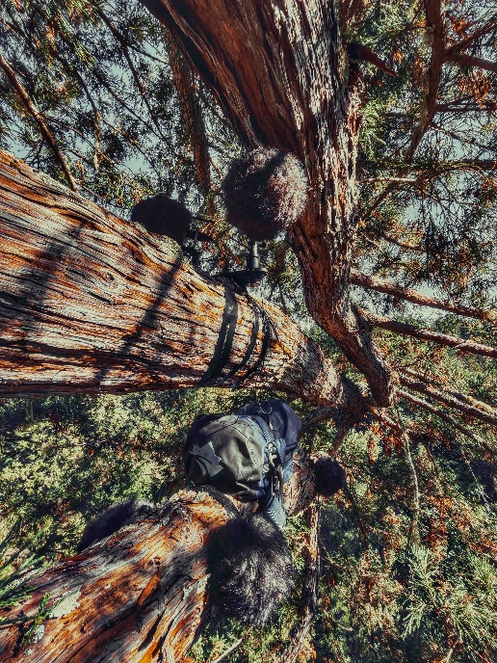 | Sennheiser MKH 8040s recording at a height of 70 metres

One of the innovative aspects of Beverly’s project was his use of 3D microphone arrays. He built a 4.0.2 setup, utilising four MKH 8020 omnidirectional mics in a square formation at the base of the tree, with two MKH 8040 positioned above them. This arrangement was designed to capture the vertical element of the forest’s soundscape, adding depth and dimension to the recordings.

Beverly’s 4.0.2 set-up with MKH 8020 and MKH 8040 on the forest floor | 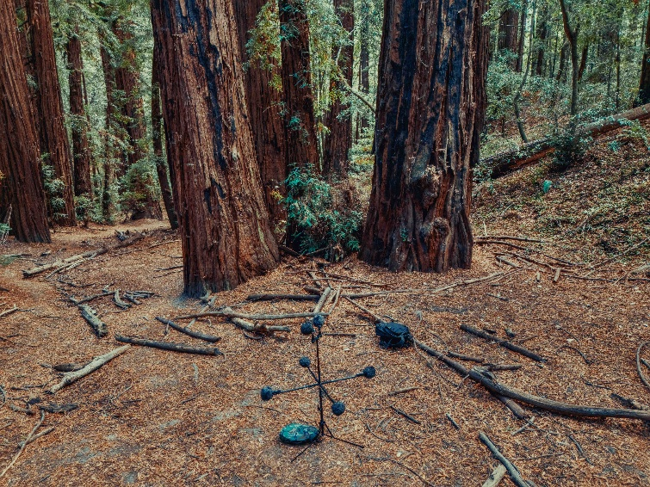

“I was really keen to build 3D mic setups with the MKH 8000 Series mics,” Beverly explains. “The 8020s and 8040s in this array were ideal for capturing the massive vertical component of this environment.”

Additionally, Beverly set up a similar array at the top of the tree to record sounds from the canopy and integrate them into a 3D mix. “The challenge was managing all the equipment, including ropes and microphones, at great heights,” he says. “But it was an amazing experience. It’s very different from recording in multiple ecosystems miles apart; this was about capturing the nuances of one tree.”

Beverly high up in the redwood tree | 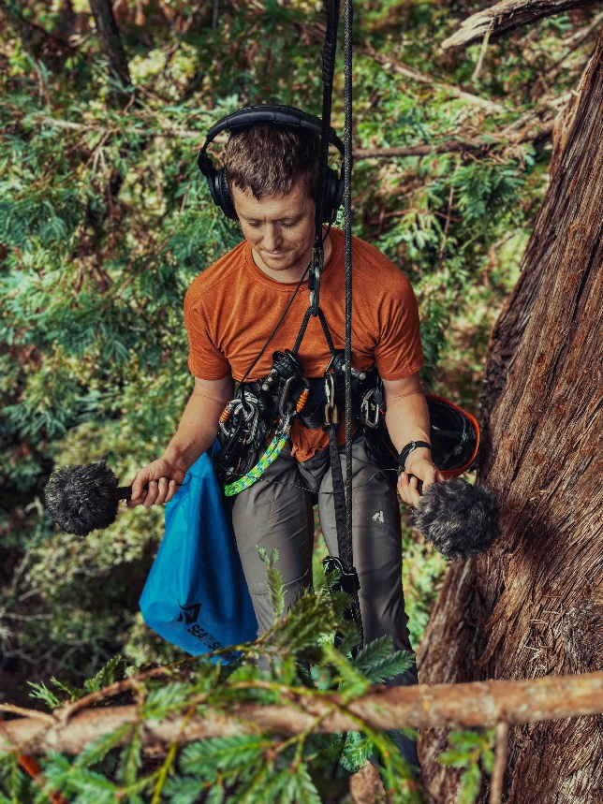

“Being in a harness for hours, dealing with batteries and SD cards, while trying to attach everything to the branches — it was tricky,” he says. “But the reward of being able to capture sounds from the tree’s canopy and juxtapose that with the sounds from the forest floor made it all worth it.”

A night up high
Beverly also spent the night in a tree boat, a hammock suspended nearly 70 metres high. “One of the most surreal moments was when I had calmed down in the hammock and started recording with my MKH 8020s. There was barely anything happening, just the faintest wind gusts moving through the canopy,” he recalls. “But that sense of space, being that high up, with distant owl calls and the wind swirling around you — it was incredible. Seeing the stars from the canopy, a lovely sunrise in the morning, and hearing the whole forest wake up with the dawn chorus, it’s quite surreal.”

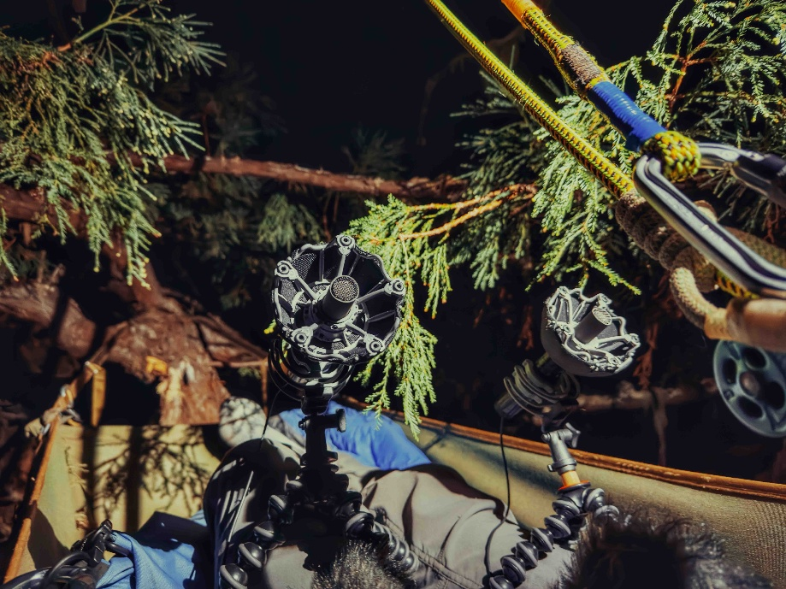 | Beverly in the tree boat with two MKH 8020s

Despite the physical challenges, Beverly found the experience deeply rewarding. “It’s one of the trickiest setups I’ve ever done, but also one of the most unique. No one has ever really tried to capture the sounds of a redwood tree canopy.”

Thomas Rex Beverly’s project to capture the soundscape of California’s redwood trees with Sennheiser microphones is a pioneering effort in nature sound recording. Through innovative setups, including 3D microphone arrays and contact mics, Beverly was able to explore the nuances of the forest’s acoustics from an entirely new perspective. This project not only sheds light on the rich and complex sound world of the redwood trees, but also demonstrates the power of high-quality microphones in capturing the delicate sounds of the natural world. Fundamentally, it is a testament to the deep connection between sound and the environment, and the importance of preserving these ancient giants.

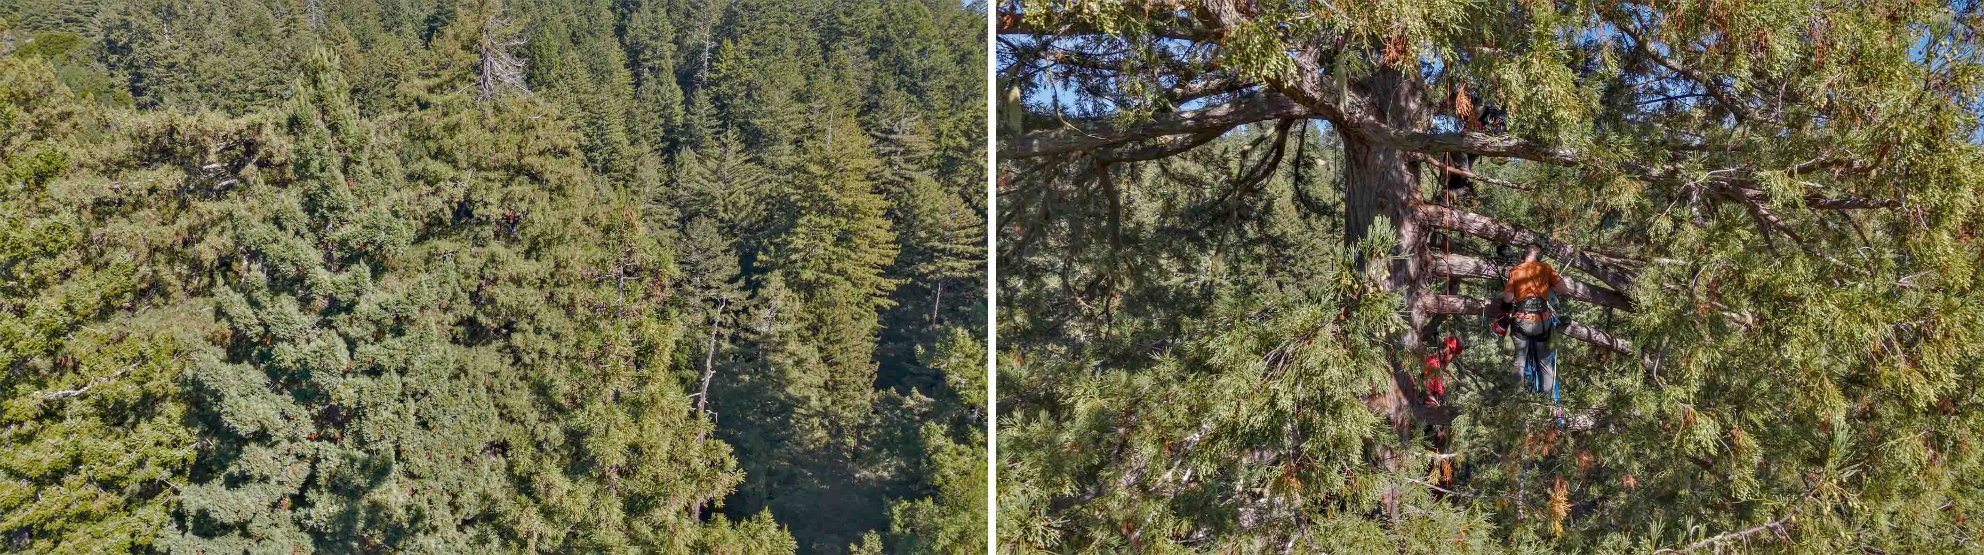
Zooming in…

Watch Thomas Rex Beverly’s behind-the-scenes video here.

If you’d like to help protect more of these ancient trees, please donate to the Sempervirens Fund at sempervirens.org.

(Ends)

The high-resolution images accompanying this media release plus additional images can be downloaded here.

About the Sennheiser Brand – 80 Years of Building the Future of Audio
We live and breathe audio. We are driven by the passion to create audio solutions that make a difference. This passion has taken us from the world’s greatest stages to the quietest listening rooms – and made Sennheiser the name behind audio that doesn’t just sound good: It feels true. In 2025, the Sennheiser brand celebrates its 80th anniversary. Since 1945, we have stood for building the future of audio and bringing remarkable sound experiences to our customers. While professional audio solutions such as microphones, meeting solutions, streaming technologies and monitoring systems are part of the business of Sennheiser electronic SE & Co. KG, the business with consumer devices such as headphones, soundbars and speech-enhanced hearables is operated by Sonova Holding AG under the license of Sennheiser.
www.sennheiser.com
www.sennheiser-hearing.com

Global Pro Audio Press Contact
Stephanie Schmidt
stephanie.schmidt@sennheiser.com
+49 (5130) 600 – 1275

